SERMON NOTES

Small Group Devotions
Week of April 23, 2017
The Resurrected Life
Transformed Worship
Romans 12:1-2
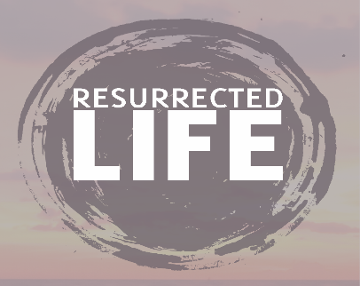

“You can’t really know Easter joy or the will of God if Jesus is relegated to the Sunday mornings of your life.”

How does Easter transform a person’s life?

How does Easter transform our worship?

Living Sacrifice

Text: Matthew 10:34-39

Presenting ourselves as living sacrifices is a difficult task. It literally means to lay our lives down for God to use us as His instruments in the world. What does it look like to offer yourself daily as a living sacrifice to God? How do the words of Jesus make that more potent or perhaps difficult?

Living a resurrected life means offering ourselves to Jesus daily, moment by moment. How do you see that happening in the normal hustle of your daily life? How could daily mediations on Scripture and prayer help you live into that resurrection?

Reasonable Worship

Text: Acts 2:37-47 (Specifically, 42-47)

Reasonable or spiritual worship is what makes sense to a rational being after encountering something as grand as the resurrection. How does offering ourselves to Him daily constitute worship? Why would the passage in Acts be important for this kind of discussion? How were their lives an everyday act of worship?

Worship, if relegated to Sundays only and not by a life lived, is not only irrational but not truly worship at all. What are some concrete disciplines you could work into your life to encourage you to live like the disciples in Acts and like Paul commands in Romans? How might this reasonable worship affect your daily life?

