SERMON NOTES

Small Group Devotions
Week of April 16, 2017
Easter
Dancing on Graves
John 20:1-18
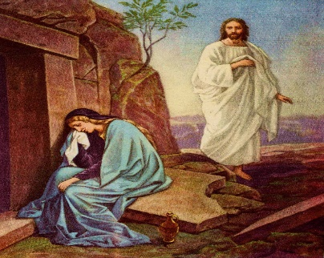

“All in our lives that is limiting, sorrowful, or dead becomes the dance floor on which we celebrate Easter joy.” Wendy Wright

Ponder on this quote and then describe what it means to you.

The Empty Tomb

Text: John 20:1-10

Before any encounter with Jesus, we must first wrestle with an empty tomb. Place yourself in any of the characters’ shoes. How would you respond to this empty tomb? Why should that alone bring you joy after such grief?

How does this passage challenge our constant desire to see “signs” before believing? How does their faith encourage you knowing that it took them so little to believe?

Jesus Chooses Her

Text: John 20:11-18

We know three things about Mary Magdaline: She was a demoniac healed by Jesus in Luke 8:2; she witnessed Jesus’ death and the place He was buried; and here in John. As you read through this encounter, what stands out to you? What do you think of how Jesus spoke to her?

Mary was inferior as a woman, spiritually suspect as a former demoniac, and legally barred from being a witness. Still, Jesus chooses her to be the first Herald of Good News. What does this mean to you? What does this mean for the world?

As you go about your week celebrating the power of the resurrection, how could you better live your life dancing like Jesus? Meaning, are there ways you can live in the resurrection more faithfully?

