SERMON NOTES

Small Group Devotions
Week of April 2, 2017
Journey to the Cross
The King No One Wants
Matthew 21:1-11
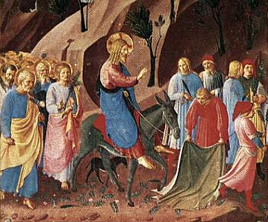

“So many people are yearning for a Kingdom not of this world but for this world.”

What does it mean to be a King?

Does Jesus fit into that definition?

The King No One Wants

Supplemental Text: Matthew 21:12-17

Just after Jesus is welcomed into town he heads to the temple and does the unthinkable: He overturns tables, rushes out money collectors, and lectures the people that were supposed to be lecturing him (they were overcharging on everything needed for the Passover). Why did this act begin to change “Hosannas” into “Crucify?” What does this say about His kingdom?

Are there tables that need overturned in your life? How does this passage challenge you to treat those around you? How would God treat them?

The King We All Need

Supplemental Text: Matthew 26 – 27:66

This is the Passion of our Lord Jesus Christ. Take some time to list out how He’s the King we all need, even if some of those are things we don’t want. As you ponder this list, how would you summarize Him? How would you summarize His kingdom? Why is that what we all need?

If this is who Jesus chooses the be, then how are we to be similar as His children? In what ways could you live a more Christlike life in light of who He chose to be for you?

