SERMON NOTES

Small Group Devotions
Week of March 5, 2017

Journey to the Cross
The Temptation of Jesus
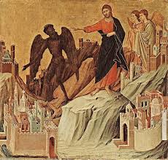

“Temptation will always come when you make space in your life for the Lord, when you’re in the wilderness.”

How would you describe temptation and its effect on our lives?

What is “God’s Will?” Is it universal or different for everyone? What does it mean to follow His will?

New Israel

Supplemental Text: Exodus 16; 17; 32

The temptation of Jesus mirrors the struggles of Israel after being delivered from Egypt - hunger, testing and idolatry. Jesus succeeds where Israel consistently failed – He is the new Israel, the Son of God. How would you describe that difference?

Does fasting and a journey through the wilderness usher in temptation? How have you experienced that? How does this story of Jesus and even that of Israel in the wilderness equip us for dealing with temptation?

Defeated Devil

Supplemental Text: Matthew 10:1; 28:18-20

Jesus defeats Satan by not fitting in with the status quo and choosing to follow God’s will. He then goes from town to town eroding the kingdom of the devil. As you think through the entire story of Jesus, how do you think He erodes the Kingdom of the Devil? How does He show that the Devil is defeated?

What does that mean for us if He’s empowered us to do the same? How do we continue the work of eroding the Kingdom of the Devil? What does any of this have to do with temptation? Are we tempted to not do those things? Is that the status quo, to let the Devil reign?

