Making it Real

Lent is an important season to ask ourselves the question, “Who’s shaping who?” In what areas of your life are you trying to make God fit into your box, your ideas of how life should be, rather than letting God shape you into His image? How would those conflict with each other?

What are some practical ways that you can take steps to surrender those areas of your life, pick up your cross and follow Him? Will you commit to doing that this Lenten season?

Verse of the Week: Mark 8:35

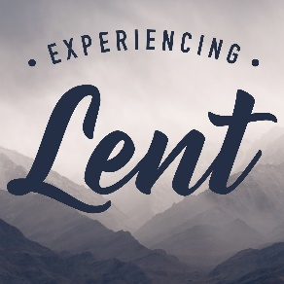
Small Group Devotions
Week of February 25, 2018
Who’s Shaping Who?
Mark 8:31-38

Sermon Notes
Who’s Shaping Who?

Shaping God

Shaping Us

Lent – Following Jesus

My Story

Looking back at your notes from this week’s teaching, was there anything you heard for the first time or that caught your attention, challenged, or confused you?

Who was/is the most influential person in your life? How did they influence you? What made it possible for that person to speak into your life like that?

Is there someone in your life that you’ve spent time trying to shape into a person you’d be proud of? Why is that important?

Digging Deeper

Text: Philippians 3:2-14
If you can remember the story of Paul (Acts 9), how does this passage show how Paul stopped trying to shape God and instead let God shape him? How exactly did that transform his life?

How does Paul exemplify discipleship in this passage? Why was it more important for Him to know Jesus and His suffering rather than the success of his life previous?

How do verses 12-14 shape your thoughts on what it means to follow Jesus to the cross in hope of attaining the resurrection?

